Cole Thoni

APCS

Period 2

How to run final code

Steps:

1. Install Ninite JDK at <https://ninite.com/jdk/>
2. Install jGRASP at <https://www.jgrasp.org/>
3. Open jGRASP and open the folder containing the program.  The folder explorer screen on the left should look like this:
4. Open the Main.java file and click the compile button at the top of the screen https://lh4.googleusercontent.com/zC8EDWzvDh16ip0M1ZvCwZLq2zbCDyTV9K-ieaP139t_-UTrGPELoZbUBrjGxU4eKcjky1sdFG03FIHZt28pJBGkKBAab72CHgQS9GMepXb5mrtlWEwuSixmKNrCDgxK-gsnG7IK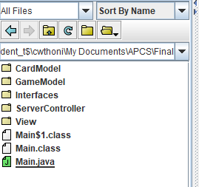
5. Once the code has compiled click the run button next to the the compile button  https://lh4.googleusercontent.com/AGk8EvSRS0Vl_ZAYKlRyFVUch1XOcla0Y_s7EF5VpVNae-FIIqIX4ANOBAptWIoJUCxTBnXGJhvU-qOy6A-CFBsnNWjPH0-RWYXy3tQOmxdPIX1WrSexgBfe_MRS3Fy2Y1D7WWhb
6. Choose the preferred game mode when prompted
7. Give a player name when prompted
8. Play!